QuArk Map Editor for Mahatta

Mahatta Maps: the compiler and Detail Brush

Mahatta maps are composed of brushes and entities. These are all stored inside files with extension: .map. When you compile your map in Quark, Quark will generate a .map file and use that for generating a .bsp file with q3map2 compiler. This is a text file, so when you open it with ‘Notepad.exe’, you will actually be able to read the contents inside the map (brushes and entities).

Brushes are made up of faces, each composed of 3 3-D points. Those three points describe two vectors, v1 = point1 – point0 and v2 = point2 – point1. You can then construct the plane’s direction by the cross product of v1 and v2 and vice versa. (Think right hand rule).

With each plane (face) of the brush, you can construct the edges and the vertices. The edges are the lines where two planes intersect. The vertices are points where three or more edges (or planes) intersect. See the diagram below:

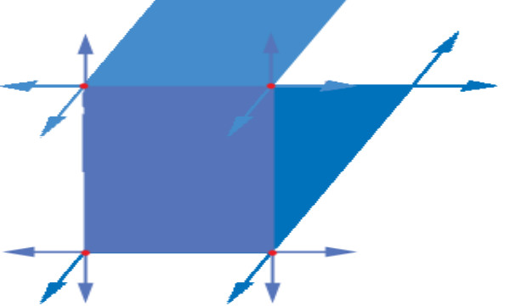

Solid squares denote the planes, arrows denote the edges and red dots denote the vertices.

Inside the .map file you will see:

{
"classname" "worldspawn"
{
brushDef
{
( -296 -608 216 ) ( -168 -608 216 ) ( -296 -480 216 ) ( ( 0.00000 -0.00781 1.81250 ) ( -0.00781 0.00000 -4.25000 ) ) base_wall/basewall03
...
}
}
{
"classname" "info_player_deathmatch"
"origin" "-248 -592 64"
"angle" "360"
}
}

You do not need to worry much about the internal components of the .map file, but at least you know what the brushes are and how entities are structured.

q3map2

Now with a .map file, q3map2 (compiler) does three things to the file:

- Calculates the full data of all brushes: the edges, vertices and such.
- Partition these newly generated brushes to binary space partition (bsp).
- Find all the portals in the map and write them to .prt file

All these happen when you execute: q3map2 <your map>.map.

Binary space partition (BSP) organizes your geometry to a binary search tree structure. Each side of the tree represents the ‘front’ and ‘back’. The top most node of the tree will divide the space in half. The second node will divide the space half again and so on until we have smaller pieces of the geometry.

The leaves (leaf nodes) of the BSP represent the small pieces of geometry. These are basically brushes that describe the entire map.

Once the BSP is constructed, portals are generated using the leaf nodes. Basically portals are the common winding two adjacent leaf nodes share. So the winding required to get from one leaf area to the next, is called the portal. Basically, like a doorway between two leaf nodes.

To view the portals of your current map, do the following:

Open a Mahatta map in QuArk.

Build the map by clicking on Mahatta and then Q3MAP (.bsp file creation), this will generate the .bsp and .prt file but will not calculate the vis.

Once the map is compiled, click on Mahatta again and then Load Portal File.
You should be able to see blue lines on the map, these are the portals:
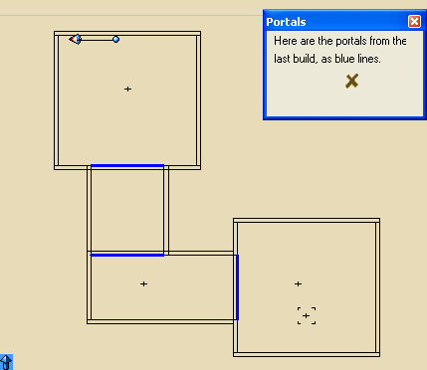

q3map2 –vis

q3map2 –vis will gather all the information from the .prt file and modify the .bsp file. The vis determines which leaf nodes are visible from every other leaf node. All of these data are stored in an NxN RLE compressed array inside the .bsp file.

To understand the vis process, let’s look at an example:

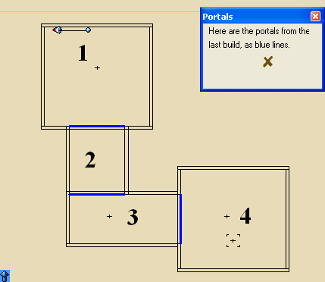

We have labeled each leaf node a number.

Let’s say you are in leaf node number 4. Which blue lines will be visible? The answer is determined by creating a line from portal 4 to its adjacent portal, 3. This line is drawn in all directions between the two portals. If the line touches another portal, the leaf nodes touching that portal are then visible.
Looking at the example, leaf nodes 2 and 3 will be visible from leaf node 4:

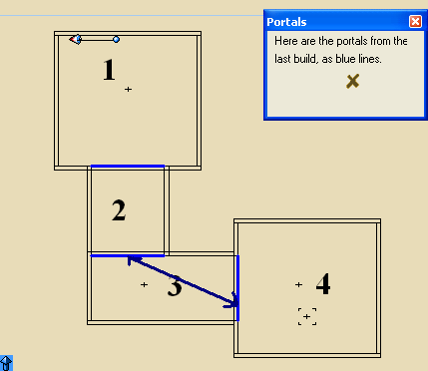

Our vis data will then comprise of:

Leaf node you are in | Leaf nodes visible
1 | 2, 3
2 | 1, 3, 4
3 | 1, 2, 4
4 | 2, 3

Basically vis tells you what leaf nodes will be drawn from the current leaf node you are standing at.
To see vis in action, load the map in Mahatta. In QuArk, do this by clicking on Mahatta and then GO!.

During gameplay, activate the console by pressing ~.

Type in: /r_showtris 1

This will display the polygons drawn by the game. You will notice that some rooms will vanish when you go to certain areas. This is the result of calculating the vis for the map.

Type in: /r_speeds 1

This shows useful rendering data.

Detail Brushes

Detail brushes are brushes that are ignored by the portal and vis calculation (line-of-sight) and thus reducing compile time.

Normally when you add brushes in the map, these brushes are defaulted to structural brushes (non-detail brush). Remember that portals and vis are calculated with every structural brushes in the map.

Add some miscellaneous geometry to a room, like furniture, rubbles, etc.:

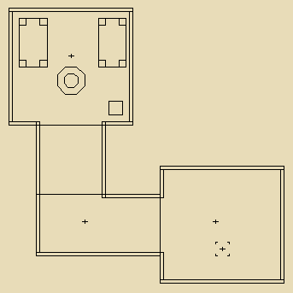
Now build the map and load the portal. You will notice how more complex the leaf nodes are split and portals cluttering the entire room:

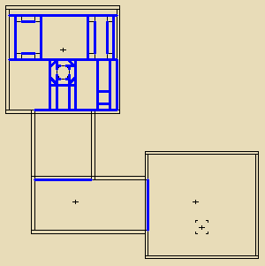

To minimize the unnecessary leaf node splitting and portal cluttering, ‘Detail Brush’ is used for brushes that are not essential to visibility determination (furnitures, rocks, statues).

To set a brush as detail, first select the brushes.

With the selected brush(es), press ‘Alt+D’ to set Detail Brush on/off. You can also do this by going to the polyhedron view and click on ‘flags for this polyhedron’, from there you can toggle the Detail Brush on/off (this also helps to determine if the brush is detail or not):

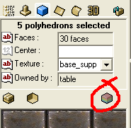

Once you set all the miscellaneous brushes to detail, rebuild your map and load the portal again. Notice how much cleaner the portals are.

NOTE: Do not set walls, ceilings, and floors to ‘Detail Brush’; this will cause leaks to map. Remember that only structural brushes are allowed to touch the outside of the map (infinite void), since q3map2 requires that it does not see them.

One other thing to know is how q3map2 splits the world every 1024x1024x1024 units. This will make q3map2 to split more leaf nodes and generate more portals. You can use this to your advantage.

Looking at the example, it is located within the 1024x1024x1024 region:

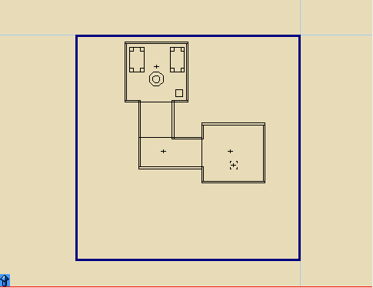

If you move the entire map a little bit outside the region, you will get this:

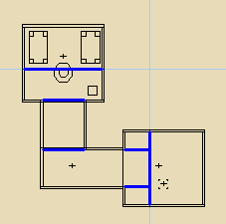
To change the size of the region you must set the key blocksize in worldspawn with values: x y z, where x/y/z is n to the power of 2 (eg: 256, 512, 1024, 2048…etc).

Highlight the worldspawn in the data display.

Click on Specifics/Args-view tab. On the arguments of blocksize enter in three numbers each separated by a space (eg: 2048 2048 2048). Rebuild the map and load the portal again.

You should really only change blocksize for large outdoor maps.

Notes on the included maps:

vis_ex_1.qkm is the simple map
vis_ex_2.qkm is like vis_ex_1.qkm but with furnitures
vis_ex_3.qkm is like vis_ex_1.qkm but with furnitures (in detail brush)

